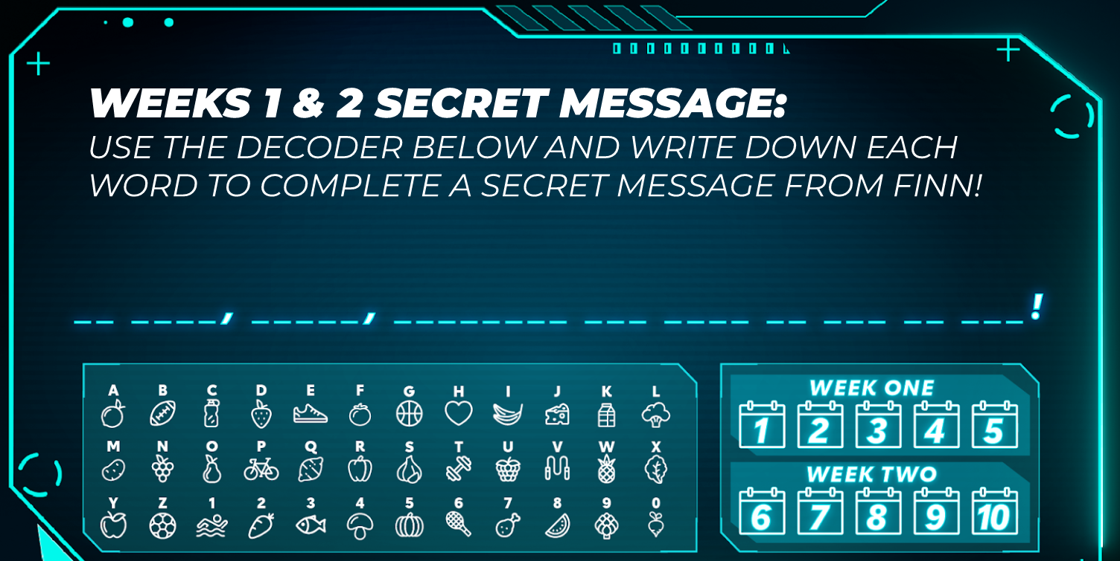

I hope you enjoyed the first week of the Kids Heart Challenge Mission Experience. Remember when you complete those missions - you will be a true Heart Hero!
Click this link for Week 2 of the Kids Heart Challenge Mission Experience: Week Two
Are you figuring out the secret code?
Don’t forget to register today so you receive your wristband!
Join the Brunswick Acres Elementary School’s team by
clicking here.
Did you choose your challenge?
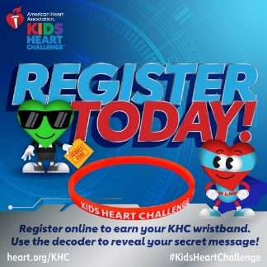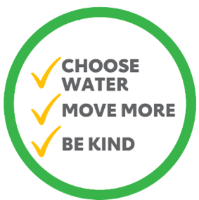

#kidsheartchallenge #hearthero #hearthealth
What do your donations support? The American Heart Association is investing a minimum of $2.5 million to investigate the cardiovascular implications of coronavirus. The Association has established a $2.5 million rapid research fund to fast-track scientific research to better understand COVID-19 and its interaction with cardiovascular and cerebrovascular diseases.

