Calling all Heart Heroes
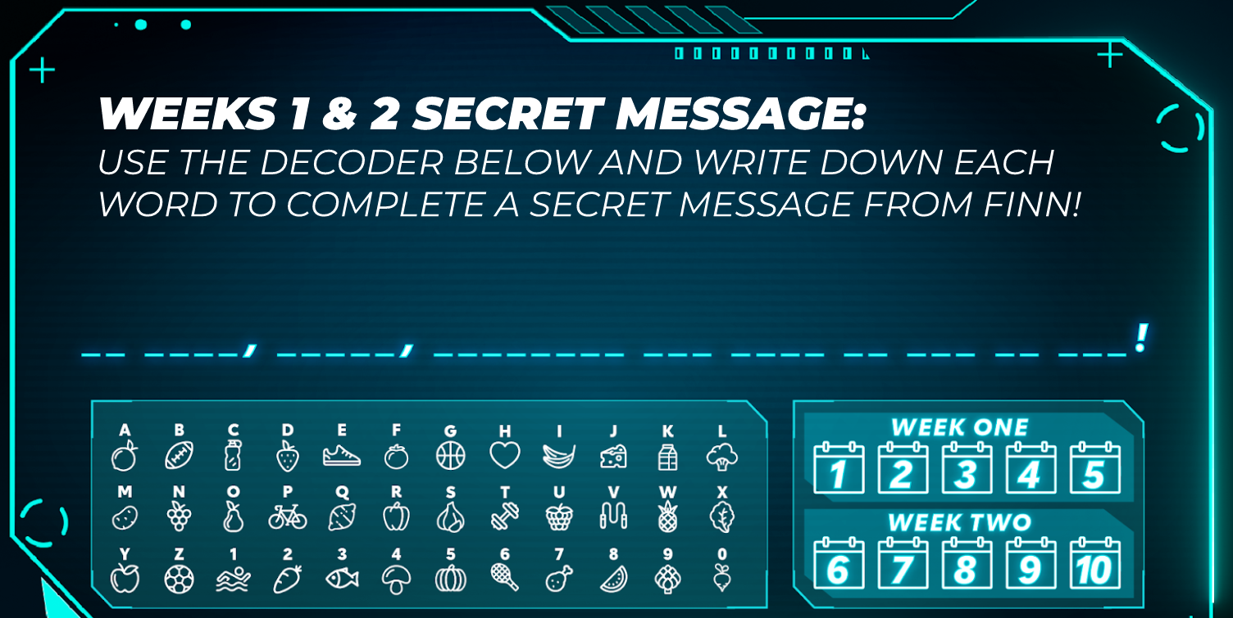

We are so excited to be participating in the Kids Heart Challenge again this year. Here is your first week of the Kids Heart Challenge Top Secret Missions. Complete those missions and you will be a true Heart Hero, prepared and ready to battle Heart Disease in your community. It is critically important that we are successful. We are counting on you!

NEW this year is a Mission Experience! Each week I will release a new week for you to go on and learn about Heart Heroes, do a daily physical challenge, as well as unlock a secret message.

Click here to join this week’s Mission Experience: Week One

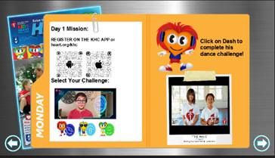

Families, we want each of our students to pledge to be heart healthy. Choose to Be Kind; Move More; or Drink Water by clicking here.
#kidsheartchallenge #hearthero #hearthealth
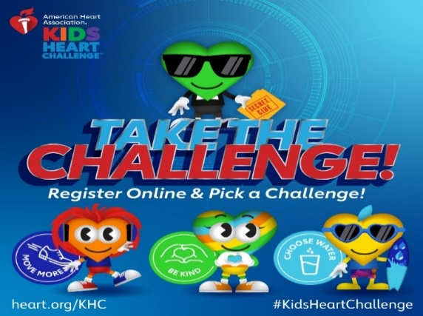

What does your donation support? The American Heart Association fights heart disease and stroke. Hypertension is one way. Uncontrolled hypertension (blood pressure) robs us of precious time with loved ones. About 1 in 2 Americans have hypertension – half of those uncontrolled. High blood pressure can be controlled, in fact, it is the most easily modifiable risk factor and the AHA is on it! Our Target BP program ensures that every patient that walks into a medical clinic will get the best treatment plan. Our CheckChangeControl program helps those with uncontrolled hypertension to get it into control. The AHA is working to expand these programs so that all Americans have access to these proven life-saving treatments. Your donation helps make that happen! Who in your life has high blood pressure? Share this link with them!

